**<http://www.instantfundas.com/2010/09/create-collapsibleexpandable-sections.html>**

**[Create collapsible/expandable sections in Word documents with More Addin](http://www.instantfundas.com/2010/09/create-collapsibleexpandable-sections.html)**

Posted on Monday, September 20, 2010 by [Kaushik](https://plus.google.com/100321795967844478622) | [3 comments](http://www.instantfundas.com/2010/09/create-collapsibleexpandable-sections.html#comment-form)

More in an interesting add-in for Microsoft Word for creating collapsible/expandable sections within a Word document, the kind we frequently encounter on web pages and many Windows applications. Usually the collapsible sections are marked with a +/- indicator or words such as “more”, or “details”. Clicking on the indicator expands the section to reveal more content. Clicking it again collapses it. More enables you to add such hidden sections to a Word document.

To create a collapsible section, the user highlights the text on the document, which can contain rich text, images, tables etc, and clicks on the ‘Standard More’ button under the ‘More’ tab in Word 2007 and Word 2010 ribbon. This inserts a collapsible section with a small marker arrow.

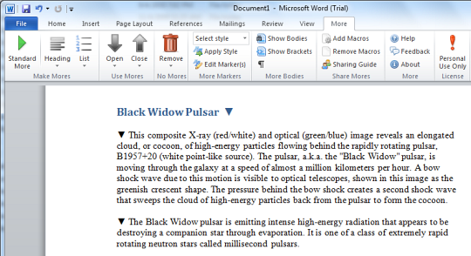

If you use Word’s built in text styling options to mark headings, you can quickly create a collapsible section for all headings on the document. A collapsed section with a heading can function as a table of contents and can be very useful for long documents with several sub-headings. Similarly you can collapse lists.

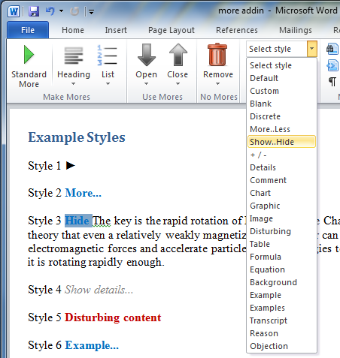coll

More lets you completely customize the marker for a collapsible/expandable section. You get various pre-defined styles and you can even define your own style by choosing a custom collapse and expand button or text.

Ideally, when send your More-laden Word document to another person, they will have to have More Add-in installed on their computer. What if they don’t? They will still be able to view the contents within the collapsible section by clicking on the “Show paragraph marks and other hidden formatting symbols” button under the Home tab.

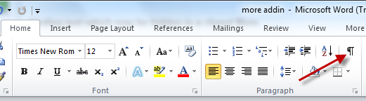

The page looks a bit awful though.

The other option is the enable Macros. If you need to share a More document with someone who doesn't have the addin installed, you need to click on the “Add Macros” button under the More tab. This will inject into the document the bare minimum macros needed to open or close Mores. Then save the document as "Word Macro-Enabled Document" (.dotm).

When you send the document to others, let them know that they will need to enable macros when prompted. Once macros is enabled the user will be able to open or close Mores.

[Download More Addin](http://www.moreaddin.com/)